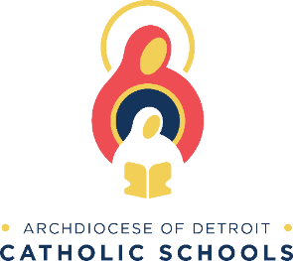
TO: School Parents/Guardians
SUBJECT: Food Allergies and Special Dietary Needs

Food Allergies and Special Dietary Needs
We recognize the critical importance of our approach to supporting students and families who manage food allergy issues every day and work closely with the families of students who have food allergies and medical conditions that require a modification to their menu. Our approach involves coordination between parents and guardians, school nurses, school administrators, and food service professionals in the school’s/district’s food allergy and medical conditions protocol.
If you would like your child to receive meal accommodations for food allergies or a medical condition impacting the diet, please ensure that you submit the required documentation to the AOD School Food Program Office by emailing the completed form to Rucker.Pam@aod.org. and that you receive confirmation that the documentation has been received and a modification plan is in place.
In order to modify the school meal, we must have a written Medical Statement on file signed by a licensed medical provider (physician, physician assistant, or nurse practitioner). The statement must identify the following:
· Information about the child’s impairment that is sufficient for understanding how it restricts the child’s diet.
· An explanation of what must be done to accommodate the child’s disability, and
· If appropriate, the food(s) to be omitted, texture modifications, and recommended substitutions.
For any children who are currently receiving meal accommodations, please contact the AOD School Food Program Office to review the meal accommodation plan, which may require additions or amendments based on the ongoing supply chain issues.

As part of our protocol, café managers review food labels for foods used to produce special meals daily; however, we are facing unprecedented food supply issues and while we are doing everything we can to minimize disruptions to our program, we do expect to experience continued shortages and substitutions. Therefore, we may encounter situations where product substitutions are made that contain different allergens or have a different nutritional profile than our usual menu items. As a result, we may need to provide a meal that is different than previously identified for students with special dietary needs to ensure that the meal served to them remains in adherence to their needs as outlined in their medical forms.
While we have posted signs in the cafeteria encouraging students with food allergies or other dietary concerns to speak up, we encourage you to remind your child to be sure to check with the cafeteria manager regarding product substitutions that may not be reflected in the posted menu.
If you have any questions regarding food service payments, Food Allergies, or Special Dietary Needs, please contact the School Food Program office at 313-883-8755 or by email at rucker.pam@aod.org.
Thank you,
Evan Manning
Director of Dining Services
Archdiocese of Detroit School Food Program

