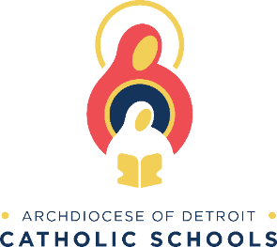
TO: School Parents/Guardians
SUBJECT: Archdiocese of Detroit School Food Program Payment Information

Student Payment Information:
To participate in the Archdiocese of Detroit (AOD) School Food Program for school year 2023-2024, meals/food must be paid for in advance online or at the sales register with a check payable to "AOD School Food Program". Please take advantage of the various options to prepay your student meal accounts. Prepaid meal accounts help the lunch lines go faster and give students more time to eat, relax, and play. It also gives you the peace of mind of not having to worry about looking for lunch money every day or worry that it might get lost, stolen, or used for things other than lunch.
Option 1: Online Payments
The Archdiocese of Detroit (AOD) School Food Program is proud to welcome Meal Magic as the recent upgrade to our program for all schools. One feature that Meal Magic allows is greater accessibility to your child's lunch account. You can now go online and make deposits, check balances and see account history.
Online deposits can be credited to your student's account in as little as 20 minutes. There is a small fee for online deposits. We will accept Discover, MasterCard & Visa credit cards, e-funds (from your bank account), and debit cards.
Parents can take advantage of the convenience of this online account access at: https://archdiocesedetroit.familyportal.cloud. You will need your student's ID number to enroll. You may contact the school for these ID numbers.
There is no fee to access account balances and/or history. You can even transfer funds deposited amongst your students if the payments were made online.

Option 2: Send Check to School
We will also accept deposits at the registers in check form as long as the check is made payable to "AOD School Food Program". There is no fee to pay by check.
You may bring money personally or send it with your student. Please place it in an envelope marked clearly with your student's name, their ID #, their teacher's name, the $ amount, and the check #.
You may give these checks to the cafeteria cashier or the school office.

Any positive balance remaining at the end of a school year will be available for the next school year or transfer with the student if the student moves to another school that uses Meal Magic. Negative balances must be paid in full by the end of the school year.

